KEEGAN TIMES: 12-7-18 vkeegan@riverdale.k12.wi.us
Reading  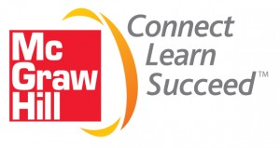  Riverdale Family Page:  ConnectED- over 800 Language Arts Activities!  Students have assignments on ConnectED each week. | - Please return reading logs every day.  - Essential Question: How do the Earth’s forces affect us?  - Genre: Expository Text  - Gives information about a topic  - Can include text features  - Vocabulary Strategy: Similes  - A simile uses the word like or as to compare two different things. To understand a simile, figure out how an author compares one thing to another.  - Example: “The two cars snap together as quick as a wink.”  - Vocabulary: amazing, force, measure, objects, proved, speed, true, weight  - Listening Comprehension strategy: reread.  - Children should reread new words to understand what they mean in the context.  - Children can also reread difficult sections or new explanations.  - Rereading can also help children remember key details.
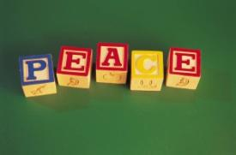  Spelling | - Words with Long a: nail, train, main, hay, stay, break, steak, weigh, sleigh, prey, scrape, strange  - Review High-Frequency Words: good, often, two, about, around, good, great, idea, often, part, second, two, world  - Pretest on Monday.
MATH Riverdale Family Page:  - REFLEX Math - Great Job earning those GREEN Lights!  - PJ Day was awesome!  - Matific –A great way to prepare for our Winter MI (Math Inventory). | Unit 3 Length and Shapes – In this Unit, children will:  -use rulers to measure lengths to the nearest whole number.  -build line plots to display measurement data.  -recognize and draw shapes.  -recognize right angles, rectangles, and parallelograms.  -name and describe two-dimensional shapes.  -Key Vocabulary: length, centimeter, line segment, square, right angle, angle, rectangle, opposite sides, triangle, and estimate.
Educational Websites | - Riverdale Page opportunities to extend the learning day:  - Reflex  - Matific  - ConnectED  - Typing Agent  - Moby Max Math and Reading
Science  Social Studies | - Riverdale page resources:  - Tumble Books: username: remschool, password: books  - PebbleGo- Username: rems Pass: school  - Google: Food Pyramid game “Blast off”  - Brain Pop, Jr.  - Essential Question: How do Earth’s forces affect us?
- Next Early Release 12/12  - K-4, Christmas Program, December 19 at 2:00.  - Class Christmas Party 12/20  - Early Release 12/21 | - Monday, Day 1: Guidance 1:10, Music 2:30  - Tuesday, Day2: PE  - Wednesday, Day 3: Art  - Thursday, Day 4: PE  - Friday, Day 5: Library
Character  Education:  Cold Weather is Here! Warm Winter clothes for recess please! | - The Riverdale Way: Accountable  - Do you have our Reading Log, Math homework, library books, shoes (PE) and homework folder each morning?  - We enjoyed learning about Manning!  - Next Star of the Week: Isabel!

